**SOFTWARE CONSTRUCTION 2**

**LAB REPORT**

**6(B)**

**BY**

**EMMANUEL DURU**

**MATRIC NUMBER: 2502665**

**GROUP 32**

**PROFESSOR WOLFGANG RENZ**

**(B - power plant)** Open a new BlueJ project with the name nuclear-power-plant. Create a new class ***PowerPlant*** with a constructor ***public PowerPlant( String name, String country, double capacity, int constructionStart, int  connectionYear)*** that stores the parameter values in the corresponding fields of the ***PowerPlant*** class. Test your constructor by instantiating "your" power plant and check it with the object inspector (screenshot into the report!). If your power plant's connection year is unknown, take -1 to code this.

**METHOD:**

I created a new class of ***PowerPlant*** with a constructor of the given parameters that was used to build up the constructor and I instantiated my ***powerPlant*** (powerpla1 and powerPla2) with the given information which was evaluated from the lab preparation Wikipedia link. Of which the object inspector is displayed below with the given information and I called the void print method to get the method calls of ***powerpla1*** *as show below.*

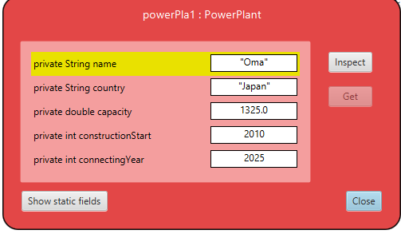

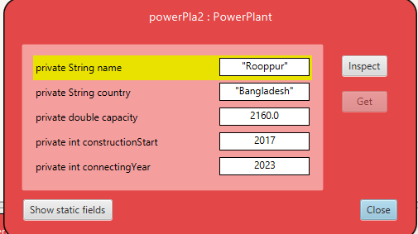

PowerPlant powerPla1 = new PowerPlant("Oma", "Japan", 1325, 2010, 2025);

PowerPlant powerPla2 = new PowerPlant("Rooppur", "Bangladesh", 2160, 2017, 2023);

powerPla1.print();

| Oma | Japan | 1325.0 | 2010 | 2025 |

**(B - table instance)** Create an instance of a nuclear power plant table as well as two nuclear power plant objects, namely  your nuclear power plant and the nuclear power plant of the row with your ID+1 taken from the wikipedia table and print it to the terminal window. Copy the recorded method calls together with the generated output into your report.

Method: I created

**METHOD:**

I created an instance of the power plantTable which I named as represented below , and I derived an object of my two given powerPlant data from the Wikipedia table and I endeavored to print the terminal window and called the void(print) method to have the recorded method calls together as shown below.

PowerPlantTable powerPla5 = new PowerPlantTable("Akpamu power plant table");

powerPla5.addPowerStation(powerPla1);

powerPla5.addPowerStation(powerPla2);

powerPla5.printTable();

| Name | Country | Capacity | Construction Start | Connecting Year |

| Oma | Japan | 1325.0 | 2010 | 2025 |

| Rooppur | Bangladesh | 2160.0 | 2017 | 2023 |